**Question:**  
"Which products have been ordered by customers who live in 'Maspeth'?"

*use bike;*

*SELECT DISTINCT p.product_name*

*FROM customer c*

*JOIN cust_order o ON c.customer_id = o.cust_order_id*

*JOIN cust_order_item od ON o.cust_order_id = od.cust_order_id*

*JOIN product p ON od.product_id = p.product_id*

*WHERE c.city = 'Maspeth';*

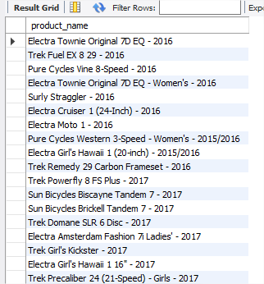

"What is the total sales value per product in the year '201706?"

*Use bike;*

*SELECT DISTINCT p.product_name, SUM(p.list_price * od.quantity) Value*

*FROM customer c*

*JOIN cust_order o ON c.customer_id = o.cust_order_id*

*JOIN cust_order_item od ON o.cust_order_id = od.cust_order_id*

*JOIN product p ON od.product_id = p.product_id*

*WHERE CONCAT(LEFT(o.order_date, 4) , SUBSTRING(o.order_date, 6, 2))= '201706'*

*GROUP BY p.product_name;*

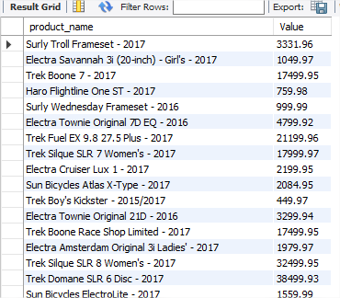

"How many customers from the customers table are located in 'New York' and have placed an order in the year 2024?"

*SELECT * FROM bike.customer c*

*INNER JOIN cust_order co ON c.customer_id = co.cust_order_id*

*WHERE c.city = 'New York';*

